**CORE JAVA**

What is software?

Software is an automation version of the manual work.

Software is an automated solution for the real world problem.

Language in software industry

C/C++/Java/Python /C#/etc

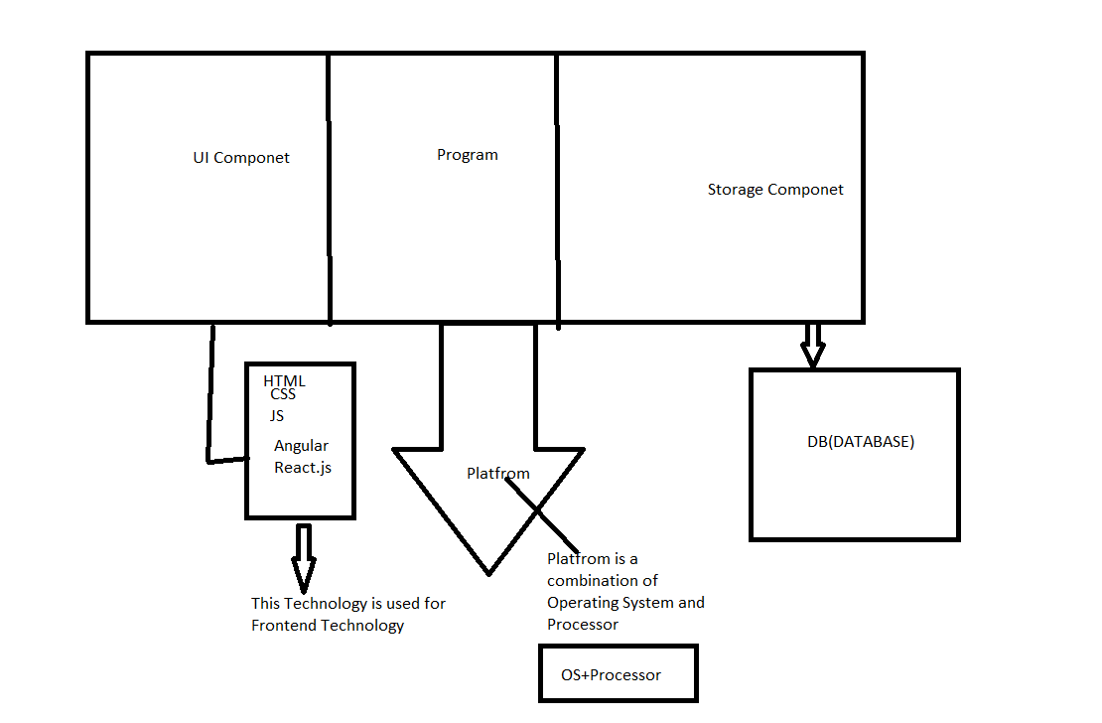

What is Program?

Program is nothing but set of instruction for platform to perform certain task.

What is Programming Language?

The language which is used for develop the program is called Programming language.

What is Markup language?